**EXPORT BARRIERS SEAFOOD INTO INTERNATIONAL MARKETS**

**Ai Tran Huu**

**ABSTRACT**

The purpose of this article is to identify the main export barriers and to test empirically their impact on exports of seafood companies, Vietnam, targeting the U.S. market. Technical barriers to trade (TBTs) exist in most industries but are particularly widespread in the international exchange of aquaculture products. Recently, a considerable number of Vietnamese seafood products have been rejected at U.S. ports because they failed to comply with U.S. regulations on environmental amenities and food safety.

***Keywords:*** *Export barriers, Export Marketing Performance, Seafood industry, Vietnam.*

JEL Classification: M11, F15, O19

1. **INTRODUCTION**

Export as an important economic activity to a firm and a driver of economic development of a nation has widely been acknowledged. In spite of numerous benefits of exporting, most firms do not export despite exporting being considered as inevitable in the increasingly integrated world markets (Papadopoulos & Martins, 2010), although the benefits derived from exporting in an increasingly globalized marketplace, for many smaller-sized manufacturers the internationalization path is beset by numerous obstacles. In particular, marketing barriers, such as product, price, distribution, promotion, procedures and logistics, occupy an important position because they often cause financial losses and negative attitudes towards international activities (Leonidou, 2002; Balabanis, 2000).

The U.S is the biggest export destination of Vietnamese product. In the year 2014 Vietnam exported 40% of the total export in the U.S. The difficulties faced by the Vietnamese frozen food sector To the U.S market is mainly related to quality and standards required by the U.S. (U.S 2012) However, exporting to the U.S requires following the standard and regulations set by the U.S market from processing up to the exporting level. Moreover, the whole process need to monitor very carefully and series of problem could arise during the export process. In addition, the problems faced by the Vietnamese seafood exporting companies in the U.S which can be attributed to a series of export barriers. (Bari 2008)

So, the research problem of this study was formulated as: What are the major barriers faced by the processing Vietnamese small and medium sized shrimp and Pangasius exporting companies in the U.S market.

**2. LITERATURE REVIEW**

The U.S and Vietnam are presently negotiating a free trade agreement (FTA), which aims to eliminate tariffs within a 7-year time frame with the target implementation date as 2013-2014. Such an agreement could transform the overall business environment from the interconnectedness of these trading economies. Bailey (1978) suggests that if trade agreements between countries and/or economic blocs are to achieve their potential and bestow benefits public policy may be required to help firms in overcoming export problems.

*Export marketing Performance*

The export performance of a firm reflects a firm-specific behavior in leveraging its resources and capabilities in an international context at a given point of time. Firm export performance is seen as one of the key indicators of the winner of a firm’s export operation, and as such, it has been an extensively studied phenomenon. Export performance has been a widely studied concept in international business literature (Shoham, 1999). The success of the firm ís export-marketing activities depend on the attitudes and characteristics of the handlers. Export marketing knowledge problems can be attributed to a large extent to the lack of trained and experienced human resources. The ideas and results that are presented in this article would shed light on the correlation between export performance, export barriers, firm size and internal management force.

*Export Barriers*

Export barriers have been broadly classified into internal and external components. While internal barriers consist of company or product related variables, external barriers include industry, market or macro-environment variables (Tesfom, and Lutz, 2006: Cavusgil and Zou, 1994). Internal barriers are connected with an insufficient organizational resource to export markets. External export barriers include the imposition of tariff barriers and regulatory import controls by foreign governments, fierce competition, exchange rate fluctuations, limited foreign exchange for international trade, and cultural differences amongst others. Results of various studies showed that exporters’ sensitivity to the barriers of foreign markets is determined through managerial perception that in its turn is affected by underlying factors in relation to the size, resource, and capability of the company and its partnership in export and its international analysis (Suarez, 2003).

1. **THE RESEARCH RELATED TO MARKETING BARRIERS**

Marketing barriers refer to obstacles in the firm’s overseas activities, such as product quality, technology, distribution, logistic, and procedure (Karelakiset al., 2008). The overall review in Table 1 shows a comprehensive picture of the effects of those marketing barriers on export performance.

**Table 1- The Literature Review of the Effect of Marketing Barriers on Export Performance.** **Source: Literature reviewed by the authors**

|  |  |  |  |  |  |
| --- | --- | --- | --- | --- | --- |
| Literature review | Product  Barrier | Logistic  Barrier | Distributive  Barrier | Procedure  Barrier | Technology  Barrier |
| Leonidou (2004) | X | X | X |  | X |
| Kaleka and Katsikeas, (1995) | X | X |  |  |  |
| Haidari, (1999). Neto (1982) |  | X | X | X | X |
| Weaver and Pak, (1990) | X | X |  | X |  |
| Kedia and Chhokar (1986) | X | X |  | X | X |
| Cheong and Chong (1988) | X |  |  | X |  |
| Weaver and Pak, (1990) | X |  | X | X |  |
| Bauerschmidtet al. (1985) | X |  | X |  | X |

Technical barriers refer to product standards that may differ from country to country. These standards can also have the effect of restricting trade. Such standards can include specifications of characteristics of any type of product and may be established by private or public bodies. Although compliance with these specifications may not be mandatory, the market may still penalize those who do not comply. Technical standards may require that products meet certain requirements before they are placed on the market.

The second export market barrier is export procedures (Haidari, 1999; Weaver and Pak, 1990). One of the most cited obstacles with regard to exporting concerns the time and paperwork required to comply with foreign and domestic market regulations. Governments do not solely impose these procedural requirements. In addition, independent organizations such as banks, shipping organizations and insurance companies, have their own procedures. The upshot is that the mere perception of inability to process the paperwork, either because of cumbersomeness or due to lack of time, constitutes a barrier to exporting.

The logistic barrier is considered as an extended dimension of the distribution barrier (Karelakis, 2008).The logistics barrier reflects the difficulties in supplying inventory in overseas markets, unavailable foreign warehousing facilities, and excessive transportation and insurance costs (Kaynak and Kothari, 1984). The lack of financial and human resources and a large geographical distance generate many problems for the firms in delivering products on time as well as maintaining the reasonable storage of products abroad.

The product barrier occurs in developing new products for foreign markets, meeting export product quality standards, adapting export product design/styles, and providing an after-sales service (Leonidou, 2004). Small and medium-sized firms often lack managerial expertise, research skills, R&D competence, and financial resources, thus limiting the firms’ fulfillment of the high-quality standards for products required by foreign markets (Leonidou, 2004). Export market barriers are related to product requirements in the export market, the country of origin, cultural similarity and brand familiarity.

The distribution barrier refers to complex foreign distribution channels, accessing export distribution channels, obtaining reliable foreign representation and maintaining control over foreign intermediaries, and facing difficulties in supplying inventory abroad (Leonidou, 2004). The complexity and length of foreign distribution channels make it difficult for firms to enter international markets. Small and medium-sized firms face a very low to a high impact of the different facets of the distribution barrier on their export performance.

**THEORETICAL MODELS AND HYPOTHESES**

**Table: 2- Measures of the variables in the model proposed. Source: Measures reviewed by the authors**

|  |  |
| --- | --- |
| **Measures** | **Measures review** |
| The products barrier | Kaleka and Katsikeas, (1995); Leonidou, (2004) |
| The technologies barrier | Christensen et al. (1987), and Dicle and Dicle (1992) |
| The distributions barrier | Keng and Juian, (1989); Leonidou, (2004) |
| The logistics barrier | Kaleka and Katsikeas, 1995; Yeung, 2006 |
| The procedures barrier | Haidari, (1999); Weaver and Pak, (1990) |
| Export marketing performance | Chung, (2003); Karunaratna and Johnson, (1997) |

Based on discussions and in-depth interviews of experts and business managers, this study explores whether different categories of marketing barriers (products, technologies, distribution, logistics, and procedures) influence export marketing performance simultaneously in the context of one industry. Because different industries have different success factors and drivers of export marketing performance (Leonidou, 2004), the following hypotheses are suggested:

H1: The products barrier has a negative effect on export marketing performance.

H2: The technologies barrier has a negative effect on export marketing performance.

H3: The distributions barrier has a negative effect on export marketing performance.

H4: The logistics barrier has a negative effect on export marketing performance.

H5: The procedures barrier has a negative effect on export marketing performance.

The theoretical model is shown in the figure below (Fig.1)

**Export marketing performance**

-

-

-

-

-

***Fig. 1: Theoretical model. Source: Research results by author***

1. **Methodology**

*Data Analysis*

This study used exploratory factor analysis (EFA) and Confirmatory factors analyses (CFA) and structural equation models (SEM) to test the hypotheses. SEM is clear and testable, thus competing models can be analyzed, synthesized and understood and, their effect whether direct, indirect or both can be investigated (Schumacker and Lomax, 2004).

*Reliability and Validity*

The internal consistency of the questionnaire was determined through calculating the Cronbach’s alpha coefficients using Stepwise Reliability Analysis. Internally inconsistent items were sequentially deleted, therefore maximizing the scales’ reliability at 0.70 (Sekaran and Bougie, 2010: 325). The Cronbach coefficient alphas were acceptable (exceeds 0.7); thus implying that the measurement instruments were fairly reliable.

*Procedure for data collection*

This study aimed to investigate the relationship between export barriers and export performance in the commercial relationship of seafood firms, Vietnam.

Thus, focusing on this industry is expected to generate a comprehensive view of the role of marketing barriers in export performance in Vietnam. In preparation for this study, we focused on three key exported products: Pangasius, shrimp, and surimi. About 300 seafood companies fulfilled the criteria and operate mainly in the south of Vietnam.

Quantitative research methods are used in this study. Theoretical models have five independent concepts measured by 24 observed concepts and one dependent concept measured by three observed concept. Scale concepts studied in theoretical models are multivariate scale. The observed concepts are measured on a 7-point Likert scale (1: strongly disagree to 7: strongly agree). To ensure that the questionnaire’s content and design would be unambiguously understood by the respondents, it was pre-tested by 7 experts. The questionnaire was then mailed to managers of these firms.

A survey questionnaire was sent by e-mail to the business managers of 300 seafood companies with labor numbers over 300. In order to increase the response ratio, the firms’ managers were contacted by phone to confirm their participation in the survey. Of the 300 questionnaires dispatched, 246 usable responses were received, representing an effective response rate of 82%. SPSS 22.0 and Amos 22.0 were used as statistical software for analyses.

*Description of the Survey*

The data collected from 246 seafood exportersin Vietnam with the characteristics are presented in Table 3.

**Table: 3- Characteristics of the sample seafood exporters in Vietnam. Source: Data analysis of research data by SPSS 22.0**

|  |  |  |
| --- | --- | --- |
| **Ownership** | **Quantity** | **Percentage** |
| Stock enterprises | 104 | 42.27 |
| Private enterprises | 142 | 57.73 |
| **Size** | **Quantity** | **100.00** |
| 300 < Firm<500 labours | 138 | 56.10 |
| Up 500 labours | 108 | 43.90 |
| **Total** | **246** | **100.00** |

The results of the EFA, summarized in Table 4, showed 24 variations observed in 5 components of the enterprise performance scale and retained 5 factors with 20 observed concepts. There are four items of excluded observed concepts: *the product barrier6, the technology barrier4, the logistic barrier4, and the logistic barrier5*.

After excluding the four concepts, the EFA results 5 factors of enterprise scale. As KMO coefficient = 0.853, EFA matches the data and the statistical test Chi-quare Bertlett 2324.641 worth 0.000 significance level. Thus, the observed concepts are correlated with each other considering the overall scope. The variance extracted by 70.028 shows that factors derived from 70.028% explained variance of the data, eigenvalues ​​in the system by 1.268. Therefore, the scale draw is acceptable. The scales have observed concepts excluded by of EFA, Cronbach’s Alpha coefficients were recalculated, and the results achieved reliability requirements.

**Table: 4- Construct, Factor Loadings, and Reliability (EFA). Source: Data analysis of research data by SPSS 22.0**

|  |  |  |  |  |  |
| --- | --- | --- | --- | --- | --- |
| **Pattern Matrixa** | | | | | |
|  | Component | | | | |
| 1 | 2 | 3 | 4 | 5 |
| The knowledge and skill to deal procedures | 0.889 |  |  |  |  |
| Foreign business practices are difficult to understand | 0.862 |  |  |  |  |
| High value of foreign currency in export markets | 0.789 |  |  |  |  |
| Confusing foreign import regulations and procedures | 0.672 |  |  |  |  |
| Customs procedures inadequate | 0.654 |  |  |  |  |
| Complexity of foreign distribution |  | 0.897 |  |  |  |
| Accessing, maintaining, and controlling |  | 0.790 |  |  |  |
| Obtaining reliable foreign representation |  | 0.789 |  |  |  |
| Cost high bonded warehouse |  | 0.686 |  |  |  |
| Developing and producing new products |  |  | 0.810 |  |  |
| Meeting the strict quality standards |  |  | 0.802 |  |  |
| Adapting export product design/styles |  |  | 0.699 |  |  |
| Product compliance, product strengths |  |  | 0.698 |  |  |
| Provide an after-sales service |  |  | 0.503 |  |  |
| Technology updates |  |  |  | 0.983 |  |
| New manufacturing techniques |  |  |  | 0.980 |  |
| Modern equipment |  |  |  | 0.690 |  |
| High insurance fees |  |  |  |  | 0.900 |
| Excessive transportation costs |  |  |  |  | 0.857 |
| Renting suitable transportation means |  |  |  |  | 0.828 |

*Confirming factor analysis (CFA)*

The correlation coefficient between the components with accompanying standard deviation (Table 5) shows us these coefficients less than 1 (with statistical significance). Therefore, the components: Products barrier, technologies barrier, logistics barrier, procedures barrier and distributions barrier are worth distinguishing.

**Table 5: Results of testing the value of distinguishing between the components**

**of the scale. Source: Data analysis of research data by SPSS 22.0**

|  |  |  |  |  |  |  |
| --- | --- | --- | --- | --- | --- | --- |
| Correlation | | | R | S.E. | C.R. | P-value |
| Procedure | <--> | Distribution | 0.583 | 0.157 | 5.302 | *** |
| Procedure | <--> | Product | 0.488 | 0.114 | 4.197 | *** |
| Procedure | <--> | Technology | 0.319 | 0.148 | 3.803 | *** |
| Procedure | <--> | Logistic | 0.453 | 0.121 | 4.804 | *** |
| distribution | <--> | Product | 0.575 | 0.148 | 4.434 | *** |
| distribution | <--> | Technology | 0.216 | 0.168 | 2.650 | 0.008 |
| distribution | <--> | Logistic | 0.392 | 0.140 | 4.178 | *** |
| Product | <--> | Technology | 0.305 | 0.132 | 3.273 | 0.001 |
| Product | <--> | Logistic | 0.306 | 0.101 | 3.127 | 0.002 |
| Technology | <--> | Logistic | 0.228 | 0.148 | 2.861 | 0.004 |

Regarding the relevance general, linear structural analysis shows this valuable model chi-squared statistic is 184.314 with 94 degrees of freedom and the value of p = 0.000. Chi-squared relative degrees of freedom according Cmin/df was 1,961 (< 2). Other indicators such as TLI = 0.930 (> 0.9), CFI = 0.945 (> 0.9) and RMSEA = 0.069 (<0.08). Therefore, this model fit the data was collected. This also allows the draw of individual judgments about the direction of the observed variables. About values ​​converge, the standardized weights of the scales are > 0.5 and with statistical significance p <0.05, so the scale achieved convergence value.

1. **Structural Equation Model Results**

Table shows the results of the goodness of fit test for the two constructs, namely, export barrier and export marketing performance and, the resultant structural models from the two data sets. From the AMOS output reflected in the table 6, it is clear that the model fitted the data well, and therefore proposed model was adequate in explaining the relationship among the variables

**Table 6: Results of the AMOS Analyses of the Resultant Models. Source: Data analysis of research data in SPSS 22.0**

|  |  |  |  |  |  |  |  |  |  |  |
| --- | --- | --- | --- | --- | --- | --- | --- | --- | --- | --- |
|  |  |  |  | **Goodness of fit Measures** | |  |  |  |  |  |
| **Model** | **X2** | **Df** | **p** | **X2/df**  **(CMIN/DF)** | **RMSEA** | **NFI** | **RFI** | **IFI** | **TLI** | **CFI** |

Sample 185.314 94 0.000 1.682 .058 .905 .902 .960 .945 .959

Criteria P>.05 ≥0 - 2 to 3 <.08 >.90 >.90 >.90 >.90 >.90

(Non-significant)

Note: X2 = chi-square test, df = Degrees of freedom, RMSEA = Root mean square error of approximation, NFI = Normed Fit Index, RFI = Relative Fit Index, IFI = Incremental Fit Index, TLI = Tucker-Lewis Index, CFI = Comparative Fit Index

*Inspection of the relationship between export marketing performance and export barriers*

Structural equation modeling (SEM) was performed to explore the relationship between the structure of export marketing performance and export barriers. Tests the basic relationship between the elements (Products barrier, technologies barrier, customers barrier, procedures barrier and distributions barrier) and export marketing performance has been run.

The results showed that this model valuable chi-squared statistic is 173.244 with 103 degrees of freedom (p = 0.000). Chi-squared relative degrees of freedom according Cmin/df was 1.682 (< 2). Other indicators such as TLI = 0.910 (> 0.9), CFI = 0.925 (> 0.9) and RMSEA = 0.058 (<0.08). Therefore, this model achieved compatibility with data already collected. However, technology barrier were excluded from the model because no statistically significant at the 95% confidence level for P = 0.170 value (> 0.05). The remaining factors include products barrier (ES = -0.522; P = 0.000); logistics barrier (ES =

-0.181; P = 0.041), distributions barrier (ES = -0.238; P = 0.020) and procedures barrier (ES = -0.263; P = 0.022) had P values <0.05 and the estimated values are normalized so negative they have direct influence, negative full value).

**Table 7: Results of estimating causal relationships between these factors export barriers. Source: Data analysis of research data by SPSS AMOS 22.0**

|  | **Relations** |  | **Estimate** | **S.E.** | **C.R.** | **P** | **Label** |
| --- | --- | --- | --- | --- | --- | --- | --- |
| EMP | <--- | Procedure | -0.263 | 0.115 | -2.286 | 0.022 | accepted |
| EMP | <--- | Distribution | -0.238 | 0.102 | -2.328 | 0.020 | accepted |
| EMP | <--- | Product | -0.552 | 0.154 | -3.582 | 0.000 | accepted |
| EMP | <--- | Logistic | -0.181 | 0.089 | -2.046 | 0.041 | accepted |
| EMP | <--- | Technology | -0.073 | 0.053 | -1.372 | 0.170 | Not accepted |

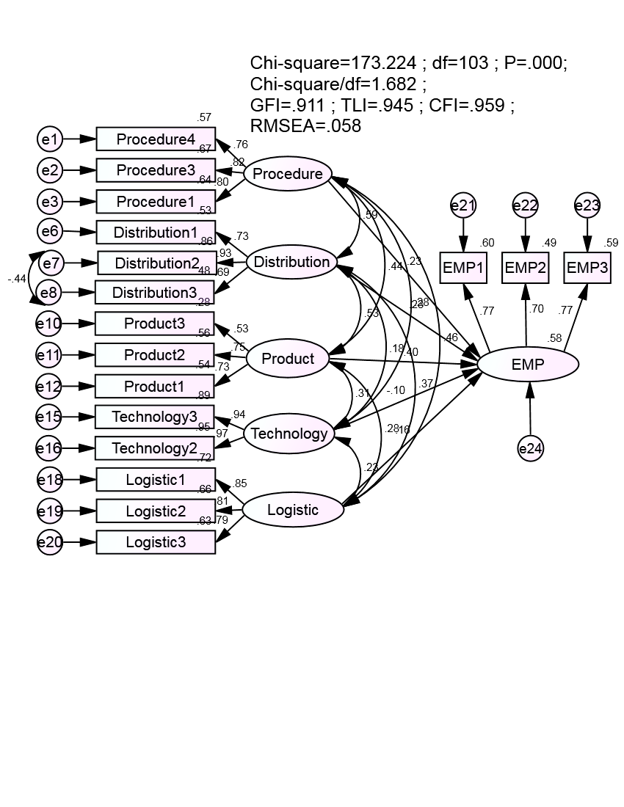

**Figure 2: Results of the model structure was SEM. Source: Data analysis of research data by SPSS AMOS 22.0**

The results showed that the model last calibration value chi-squared statistic is 131.915 with 79 degrees of freedom (p = 0.000). Chi-squared relative degrees of freedom according Cmin/df was 1.670 (<2). Other indicators such as GFI = 0.923 (> 0.9), TLI = 0.945 (> 0.9), CFI = 0.959 (> 0.9) and RMSEA = 0.058 (<0.08). Therefore, this model achieved compatibility with data already collected.

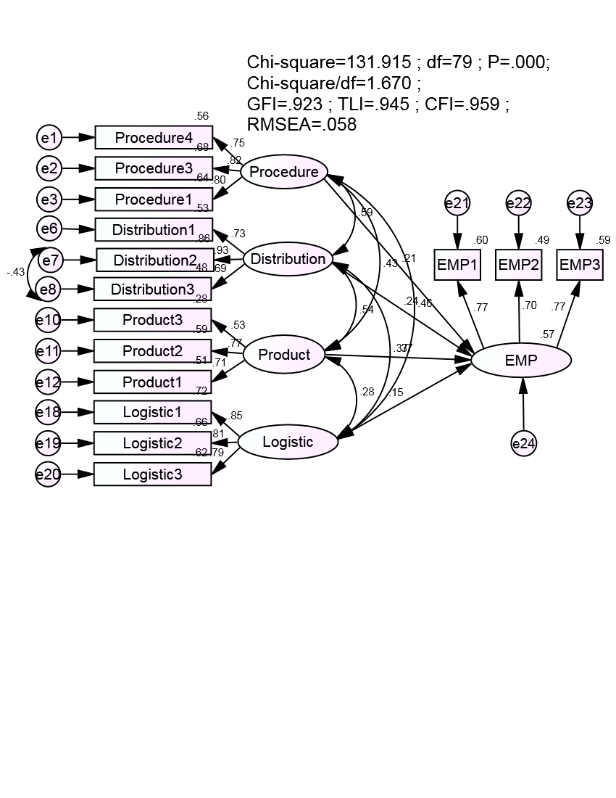

**Figure 3: Results of the model structure was last calibrated SEM. Source: Data analysis of research data by SPSS AMOS 22.0**

**Table 8: Results of estimating causal relationships between the elements of factors export barriers. Source: Data analysis of research data by SPSS AMOS 22.0**

|  | **Relations** |  | **Estimate** | **S.E.** | **C.R.** | **P** | **Label** |
| --- | --- | --- | --- | --- | --- | --- | --- |
| EMP | <--- | Procedure | -0.263 | 0.115 | -2.286 | 0.022 | accepted |
| EMP | <--- | Distribution | -0.238 | 0.102 | -2.328 | 0.020 | accepted |
| EMP | <--- | Product | -0.552 | 0.154 | -3.582 | 0.000 | accepted |
| EMP | <--- | Logistic | -0.181 | 0.089 | -2.046 | 0.041 | accepted |

*Testing the reliability of estimates by Bootstrap*

Bootstrap method used to test the model estimates the last model with the pattern repeat is N = 1000. The estimation results from 1000 samples are averaged together with the deviations are presented in Table 9 , CR very small absolute value than 2, it can be said that the deviation is very small; while not statistically significant at the 95% confidence level. Thus, we can conclude that the model estimates can be trusted.

As a result of testing of hypotheses for export marketing performance, the hypothesis H1, H2, H3 and H4 of the export barrier that are same direction relationship with the export marketing performance and are accepted. There are four relationships are worth theoretically.

**Table 9: Results estimated by bootstrap with N = 1000. Source: Data analysis of research data by SPSS AMOS 22.0**

|  |  |  |  |  |  |  |  |  |  |
| --- | --- | --- | --- | --- | --- | --- | --- | --- | --- |
|  |  |  |  | **Estimated standard** | |  | **Estimated Bootstrap N=1000** | | |
| **Parameter** | | | **Estimate** | **SE** | **SE-SE** | **Mean** | **Bias** | **SE-Bias** | **CR** |
| EMP | <--- | Procedure | -0.247 | 0.142 | 0.003 | 0.257 | -0.010 | 0.004 | -2.500 |
| EMP | <--- | Distribution | -0.249 | 0.134 | 0.003 | 0.257 | -0.008 | 0.004 | -2.000 |
| EMP | <--- | Product | -0.519 | 0.200 | 0.004 | 0.507 | -0.012 | 0.006 | -2.000 |
| EMP | <--- | Logistic | -0.173 | 0.099 | 0.002 | 0.16 | -0.014 | 0.003 | -4.667 |

**6. CONCLUSION**

***6.1. Results and Discussion***

This study extends the previous studies (Leonidou, 2000) by analyzing and assessing the impact of trade barriers (product, technology, distribution, logistics and procedure) of export performance in a commercial industry homogeneous distribution and production environments. The study used data from the fishery industry of Vietnam, has inherited the previous studies, conducted mainly in the Western countries.

The results confirm the negative relationship between products barrier for export performance (ES = -0.552, p = 0.000 <0.05). This result is consistent with most previous studies (Karelakis et al, 2008). However, whereas most previous studies here in the developed countries showed the Vietnam.

The findings show a negative effect of the procedures barrier on export marketing performance (ES = –0.263, p = 0.022 <0.05). This result is similar to those of most previous studies (Leonidou, 2000) importance of the product barriers is the weakest (Leonidou, 2004), this study confirms the product barrier to be the most important predictor of the export performance of seafood companies in Vietnam. The procedures barrier is also found to be the second most important predictor of export performance in the industry. It is argued that in the context of venture management characteristics, a firm’s capability and constraints (strengths & weaknesses) influence their choice of marketing strategy and ability to execute a chosen strategy (Aaker, 1988).

The present results also confirm a negative relationship between the distribution barrier and export marketing performance (ES = –0.238, p = 0.020 < 0.05). This result is consistent with most previous studies (Leonidou, 2002). Although the distribution barrier’s impact on export performance is weaker than that of the product and price barriers in the industry, the magnitude of its effect is relatively strong. In fact, most export markets in the seafood industry are in developed countries. Therefore, this complexity of the distribution systems creates serious difficulties for the firms.

The findings also reveal a negative effect of the logistics barrier on export marketing performance (ES = –0.181, p= 0.041 < 0.05). This result is consistent with most previous studies (Katsikeas, 2008). Although the export revenue has continuously increased in recent years, the export markets of the firms focus mainly on the US, the EU, and Japan; the great geographical distance increases the transportation costs as well as limiting the ability to supply adequately. In addition, most firms have no warehousing facilities abroad. Thus, the flow of products to the host markets is not constant and is sometimes delayed. As a result, the logistics barrier can decrease the firms’ competitiveness in international markets.

Finally, the results do not support a negative relationship between technology barrier and export marketing performance (ES = -0.073, p= 0.170 > 0.05). This result is inconsistent with most previous studies (Koksal, M.H. and Kettaneh, T., 2011). However, it is worth noticing that although the effect of the technology barrier on export performance is not significant, the technology barrier correlates highly with other marketing barriers. Thus, its effect on export performance may occur indirectly through other barriers, such as product, price, or distribution. As a result, it would be a mistake to ignore the role of the technology barrier in export performance. In fact, not many seafood firms in Vietnam can carry out their technology strategy by new model technology effectively.

***6.2. Implications for practical trading***

This study has implications for the management of commercial and industrial sector. First, the seafood company should pay attention to the various trade barriers based on the impact to reduce or improve export performance. Despite the importance of each type of barriers, as well as every aspect of every category, most of the aspects of trade barriers play a certain role in the export performance. This means that managers and traders should have a comprehensive view of the limitations of the barriers to trade mixed strategy of the company. A combination of tight link between the activities of the members of the company and build a mechanism for sharing information as well as the use of common resources can be a good solution to overcome institutional barriers to trade on the international market.

As far as adapting to foreign market needs were concerned, the study findings have shown that managers of export firms should make efforts to adapt their products/services to meet the needs of the local market to achieve success in the marketing performance of their export market venture. Specifically, differences in product usage in various foreign markets, language and cultural differences, the need to modify pricing and promotional policies according to the condition of the foreign market and the need to adapt products to meet foreign customer preferences all require management’s attention. Export managers must be aware of the importance of adapting the venture’s products/services to meet the needs of the local market and refrain from opting for a globally standardized product/service for export marketing success.

Export assistance and promotion programs are designed to increase the Vietnamese seafood export industry, and those programs have evolved to focus on encouraging exports among small to medium sized firms. From a firm perspective, the programs are designed to bridge information gaps about international markets and assist in the initial pursuit of international markets.

***6.3. Suggestions for Further Research***

Further research should be conducted into the effect of these barriers to export on export marketing performance using a much larger sample in a different national setting to validate the findings of this study and to see if the measures developed here are statistically reliable and valid across different national settings. Future studies would benefit from exploring other barriers (e.g., Capability of Firm, experienced business staff, informational or environmental) that affect export performance. The results presented here are based on self-reported measures of export performance relating to the Vietnamese seafood industry. Objective measures of export performance could be used to increase the generalizability of the study.

Finally, this study has contributed to a more comprehensive understanding of the barriers to export that impact export marketing performance. Export venture management characteristics and adapting to foreign market needs have emerged as the key barriers to export that impact export marketing performance significantly.

**References:**

1. Aaker, D. A. (1988). “Strategic *Market Management”*. Second Edition. New York: John Wiley and Sons.
2. Baldauf, A., D. W. Cravens, et al. (2000). Examining Determinants of Export Performance in Small Open Economies, *Journal of World Business 35* (1), 61-79.
3. Barney J, 1991, “Firm resources and sustained competitive advantage”. *Journal of Management*, (17), 99-120.
4. Barker, A.T. & Kaynak, E. (1992). An empirical investigation of the differences between initiating and continuing exporters. *European Journal of Marketing*, 26 (3), 27-36.
5. Bilkey, W. J. (1978) “An Attempted Integration of the Literature on the Export Behavior of Firms”, *Journal of International Business Studies*, (9), 33-46.
6. Bilkey, W.J., (1982). Variables Associated with Export Profitability. *Journal of International Business Studies,* Vol. 13, 39-55.
7. Da Silva, P., & Da Rocha, A. (2000). Perception of export barriers to Mercosur by Brazilian firms. *International Marketing Review,* 18(6), 589-610.
8. Gripsrud, G. (1990). The Determinants of Export Decisions and Attitudes to a Distant Market: Norwegian Fishery Exports to Japan. *Journal of International Business Studies* 21(3), 469–85.
9. Gehlher, Mark and Erik Dohlman. (2009). A Weakening Global Economy Interrupts Agricultural Trade. *Amber Waves,* 7(2), 22-29.
10. Haidari, I. (1999), "Leather and leather goods in Pakistan", *Economic Review,* Vol. 30, 3.
11. Ibeh, K.I.N. (2004). Furthering export participation in less performing developing countries: the effect of entrepreneurial orientation and managerial capacity factors. *International Journal of Social Economics*, Vol. 3, 94-110.
12. Karelakis, C., Mattas, K. & Chryssochoidis, G. 2008 (Online) Export Problems Perceptions and Clustering of Greek Wine Firms. *Euro Med Journal of Business,* Vol. 3

(1), 6-22.

1. Kettaneh, T., M.H, (2011). Export problems experienced by high- and low-performing manufacturing companies: A comparative study. *Asia Pacific Journal of Marketing and Logistics,* 23(1), 108-126.
2. Koh, A.C. (1991). Relationships among Organizational Characteristics, Marketing Strategy and Export Performance. *International Marketing Review*, (3), 18-26.
3. Koksal MH (2008). How export-marketing research affects company export performance: Evidence from Turkish companies. *Mark. Intel. Plan. J*., 26(4), 416-430
4. Katsikeas, C., & Morgan, R. (1994). Differences in perceptions of exporting problems based on firm size and export marketing experience. *European Journal of Marketing*. 28(5), 17-35.
5. Leonidou, L. C. (2004). An Analysis of the Barriers Hindering Small Business Export Development. *Journal of Small Business Management* 42(3), 279-302.
6. Matanda, M.J., and Freeman, S., (2009). “Effect of perceived environmental uncertainty on exporter-importer inter-organizational relationships and export performance improvement”. *International Business Review*, (18), 89-107.
7. Pett, T. and Wolff, J. (2000). Internationalization of small firms: An examination of export competitive patterns, firm’s size, and export performance. *Journal of Small Business Management*. 38(2), 34 – 47.
8. Ortega, S., (2003). Export barriers: Insights from small and medium-sized firms. *International Small Business Journal*, 21(4), 403-419.
9. Pett, T. and Wolff, J. (2003). Firm characteristics and managerial perceptions of NAFTA: An assessment of export implications for U.S. SMEs *Journal of Small Business Management,* **41**(2), 117–32.
10. Papadopoulos, N. & Martin, O. (2010). Toward a model of the relationship between internationalization and export performance. *International Business Review,* 19(4), 388-406. doi: http://dx.doi.org/10.1016/j.ibusrev.2010.02.003.
11. Ramaswami, S. N., and Yang, Y. (1990). *Perceived Barriers to Exporting and Export Assistance Requirements’, in S. T. Cavusgil and M. R. Czinkota (ads).* International Perspectives on Trade Promotion and Assistance*,* and Westport, CT: Quorum Books.
12. Sekaran, U., & Bougie, R. (2010). *Research methods for business: A skill building approach* (5th ed.). West Sussex, UK: John Wiley & Sons Ltd.
13. Shoham, A., & Albaum, G. (1995). Reducing the impact of barriers to exporting: A managerial perspective. *Journal of International Marketing*, 3(4), 85-106.
14. Stottinger, B. (2001). Strategic export pricing: A long and winding road. *Journal of International Marketing,* 9(1), 40-63.
15. Sousa Carlos M.P., Bradley Frank ,(2008), Antecedents of international pricing adaptation and export performance*, Journal of World Business* (43), 307–320.
16. Suarez-Ortega SM, (2003). Export barriers: Insights from small and medium-sized firms. *International Small Business Journal*, 21(4), 403-419.
17. Schumacker, R. E., & Lomax, R. G. (2004). *A beginner’s guide to structural equation modeling*. New Jersey: Lawrence Erlbaum Associates.
18. Sullivan, D., & Bauershmidt, A. (1989). Common factors underlying barriers to export: A comparative study in the European and US paper industry. *Management International Review*, 29(2), 17-32.
19. Tesfom, G. & Lutz, C. 2006(Online) A Classification of Export Marketing Problems of

Small and Medium Sized Manufacturing Firms in Developing Countries. *International*

*Journal of Emerging Markets*, Vol. 1(3), 262-281

1. United Nations Economic and Social Commission for Asia and the Pacific 2012 (Online) SMEs in asia and the pacific.

<http://www.unescap.org/tid/publication/>Tipub2540_chap1.pdf Retrieved 16.11.2012