**Factors Affecting Green Purchasing Behavior**

**Ai Tran Huu**

**Abstract**

This study purpose to provide information about the impact of green marketing on consumers buying behaviors, although environmental problem have changed one of the most important shopping standard to consumers, they do not show any tendency to use green products. Thus, the green marketing emerged are mentioned and then the concepts of green marketing and green consumer are explained. Reviewing the literature and using expert opinions, 5 factors of the green purchasing behavior were identified. A structured questionnaire was applied to survey 311 consumers. Then, a structural equation model was developed to determine which dimension has a greater negative effect on green purchasing behavior. According to the results of the analysis, Environmental concern and attitude, Perceived seriousness of environmental problems,Perceived consumer effectiveness and Perceived environmental responsibility were significantly affecting green purchasing behavior.

**Keywords:** Green Marketing, Green purchasing behavior, Environmental, Consumers

JEL Classification: M31, F18, O44

1. **Introduction**

Although environmental issues influence all human activities, few academic disciplines have integrated green issues into their literature. This is especially true of marketing. As society becomes more concerned with the natural environment, businesses have begun to modify their behavior in an attempt to address society's "new" concerns. Green marketing notified that green marketing is well integrated within the company’s strategy. According to Awan, U. et al. (2010) green marketing as a holistic management process responsible for identifying, anticipating and satisfying the requirements of customers and society in a profitable and sustainable way (Macdonald, S, et al., 2006). Points out that green marketing are a process which includes all marketing activities that are developmentally to trigger and to sustain consumers‟ environmental attitudes and behaviors.

For marketing, the challenge is twofold. In the short term, ecological and social issues have become significant external influences on companies and the markets within which they operate. In the longer term, the pursuit of sustainability will demand fundamental changes to the management paradigm which underpins marketing and the other business functions (Shrivastava, 1994).

One business area where environmental issues have received a great deal of discussion in the popular and professional press is marketing. Terms like "Green Marketing" and "Environmental Marketing" appear frequently in the popular press. Many governments around the world have become so concerned about green marketing activities that they have attempted to regulate them (Polonsky 1994a). One of the biggest problems with the green marketing area is that there has been little attempt to academically examine environmental or green marketing.

Previous study in Western cultures and Hong Kong had showed gender differences in environmental perceptions, values and actions. In Hong Kong, female adolescent consumers have higher scores in environmental attitude, environmental concern, perceived seriousness of environmental problems, perceived environmental responsibility, peer influence and green purchasing behavior (Lee, 2009).

**2. Literature Review**

**What is green marketing?**

Green marketing incorporates a broad range of activities, including product modification, changes to the production process, packaging changes, as well as modifying advertising. However, to define green marketing is not a simple task. The terminology used in this area has varied; it includes Green Marketing, Environmental Marketing and Ecological Marketing (Akter, 2012).

Green Marketing is integrating business practices and products that are friendly to the environment while also meeting the needs of the consumers. According to the American Marketing Association, green marketing is the marketing of products that are presumed to be environmentally safe (Nupur, 2011). Green marketing is the marketing of eco-friendly sustainable products that continue to achieve steady sales even during adverse condition, especially among eco-aware customers. The proceedings of this workshop resulted in one of the first books on green marketing entitled "Ecological Marketing" (Henion and Kinnear 1976a) . Since that time a number of other books on the topic have been published (Charter et al., 2001).

**Societal marketing**

Societal marketing refers to the use of commercial marketing concepts and tools to promote social ideas and causes. The main reason or motives of societal marketing is not profit, it’s primarily for social changes. Some examples of societal marketing programs are: anti smoking, breast cancer prevention, safety driving, etc. (Idowu et al., 2009) Societal Marketing has been used as an umbrella term that encompasses many marketing types, which involve social issues such as cause related marketing, ethical marketing and most importantly Green Marketing (Idowu et al., 2009)

**Green consumer**

The green consumer is generally defined as one who adopts environmentally-friendly behaviors and/or who purchases green products over the standard alternatives. Green consumers are more internal-controlled as they believe that an individual consumer can be effective in environmental protection. Thus, they feel that the job of environmental protection should not be left to the government, business, environmentalists and scientists only; they as consumers can also play a part. They are also less dogmatic and more open-minded or tolerant toward new products and ideas. Their open-mindedness helps them to accept green products and behaviors, more readily (Shamdasani at all. 1993:491).

**Green purchasing behavior**

Many other literatures about environmental behavior mostly speaking about environmental behavior in general, a few have been addressed specifically about green purchasing behavior (Lee, 2009). Green purchasing behavior can be translated to the act of consuming products that are conceivable, beneficial for the environment, and responding to environmental concern (Lee, 2009)

Respond in to environmental concern, one of the ways related to waste management system is by doing the 3R (Reduce, Reuse, and Recycle). To date, social influence has been found as the most important factors that affect green purchasing behavior of adolescents, however there are several more factors which are: Environmental attitude, Environmental concern, Perceived seriousness of environmental problems, Perceived environmental responsibility, Perceived effectiveness of environmental behavior, and concern of self-image in environmental protection (Lee, 2008).

**Environmental concern and attitude (ECA)**

Fundamental to environmental research is an individual’s concern for the environment (Hines et al., 1987). Based on the pioneering research of Dunlap et al., (1978), environmental concern is defined as a global attitude with indirect effects on behavior through behavioral intention. Crosby et al., (1981) mentioned that environmental concern is a strong attitude towards preserving the environment. Attitudes are defined as the enduring positive or negative feeling about some person, object, or issue. In fact, it refers to the information a person has about a person, object, or issue (Newhouse, 1991). The social psychology literature on behavioral research has established attitudes as important predictors of behavior, behavioral intention, and explanatory factors of variation in individual behavior (Kotchen & Reiling, 2000).

Seguin et al., (1998) have argued that environmental concern can have a significant bearing on the degree to which individuals are motivated to change behavioral practices so as to attempt to alleviate the problem. In a number of studies, environmental concern has been found to be a major determinant of buying organic and green food e.g. (Grunert, 1993). From the above discussions the first hypothesis can be suggested:

H1: *Environmental concern and attitude have a positive influence with green purchasing behavior*

**Perceived consumer effectiveness (PCE)**

Perceived Consumer Effectiveness PCE) refers to the extent to which individuals believe that their actions make a difference in solving a problem Ellen et al., ( 1991). Accordingly, Kim et al., (2005) argued, that individuals with a strong belief that their environmentally conscious behavior will result in a positive outcome, are more likely to engage in such behaviors in support of their concerns for the environment. Hence, self-efficacy beliefs may influence the likelihood of performing green purchase behavior. From the above discussions the second hypothesis can be suggested:

H2: *Perceived Consumer Effectiveness**have a positive influence with green purchasing behavior.*

**Perceived seriousness of environmental problems (PSE)**

According to Lee (2008) teenagers in Hong Kong perceived the seriousness of environmental problems as the least important factor in influencing the green purchasing behavior. The reason behind this was known due to repetitive exposures, which makes them react negatively. However, it is found that Asian people rate environmental problems as more severe than those who live in western countries (Lee, 2009). From the above discussions the third hypothesis can be suggested:

H3: *Perceived seriousness of environmental problems has a positive influence with green purchasing behavior*.

**Perceived environmental responsibility (PER)**

Citizens of Hong Kong have a high awareness of environmental problems, because they have attained more environmental knowledge, but their perceived environmental responsibility is weak (Li, 2008). Among adolescents of Hong Kong, perceived environmental responsibility is one of the important factors that affect their green purchasing behavior (Lee, 2008). From the above discussions the fourth hypothesis can be suggested:

*H4: Perceived environmental responsibility has a positive influence with green purchasing behavior.*

**Perceived effectiveness of environmental behavior (PEE)**

This is related to one’s perception to contribute good things to the environment by involving him/herself in pro-environmental behavior or movement. The perceived effectiveness of environmental behavior is the fifth predictor of green purchasing behavior among adolescents in Hong Kong (Lee, 2008). From the above discussions the fifth hypothesis can be suggested:

H5: *Perceived effectiveness of environmental behavior has a positive influence with green purchasing behavior.*

Environmental concern

and attitude (ECA)

Perceived Environmental Responsibility (PER)

Perceived seriousness of environmental problems (PSE)

Perceived effectiveness of environmental behavior (PEE)

Perceived Consumer Effectiveness (PCE)

**Green purchasing behavior**

+

+

+

+

+

Fig. 1: Theoretical model**.** Source: Research results by author

**3. Research Methodology**

The main objective of this study is "measuring Factors Affecting Green Purchasing Behavior". The research model of the current research is established on the basis of the Chen & Chang (2012) study as depicted in Figure 1. In this model Environmental concern and attitude, Perceived consumer effectiveness, Perceived seriousness of environmental problems, Perceived environmental responsibility and Perceived effectiveness of environmental behavior are independent variables; green purchasing behavior is a mediating variable and Green purchasing behavior is a dependent variable

Before the actual research, pretest was performed to 30 consumers to test questions in order to get feedbacks from respondents and also to see the reliability and validity of the questions itself. The questionnaires were divided into two parts. First part was questioned to represent the dimension of green purchase behavior which consisted of 27 questions measured by 7 point Likert scale. The second part was the general demographic questions such as gender, age, occupation and monthly expenses. There were also questions regarding the media, product and brand that respondents know about the green ad or activities as well the product and brand that they usually bought.

*Reliability and Validity*

First, statistical analysis to calculate both the factor analysis and the scale reliability analysis, before carrying out factor analyses, a reliability analysis of the scale was run through Cronbach’s alpha. The reliability of the questionnaire was 0.848, which is in the acceptable range. Therefore, scales of this study have a rather high level of internal consistency and are reliable. The concept scales of the study are preliminary assessed and screened by EFA method and Cronbach’s Alpha coefficients for each component. Selection criteria are satisfied when concepts have correlation coefficients turn-total (item-total correlation) >0.30, Cronbach’s alpha coefficients > 0.60; system load factor (factor loading) >0.40; total variance extracted for ≥ 50% (Hair & CTG, 1998).

*Data screening and analysis*

Quantitative research methods are used in this study. Theoretical models have five independent concepts measured by 24 observed concepts and one dependent concept measured by 03 observed concept. Scale concepts studied in theoretical models are multivariate scale. The observed concepts are measured on a 7-point Likert scale (1: strongly disagree to 7: strongly agree). To ensure that the questionnaire’s content and design would be unambiguously understood by the respondents, it was pre-tested by 7 experts (Four academic professors in the international business field, three consultants in economics and international business), and the questionnaire was revised in light of their comments. The questionnaire was then mailed to customers

A sample of 325 customers was drawn, using the systematic sampling method. The respondents who fully completed their questionnaires during the group administration process were taken as the sample. Finally there are 311 valid samples were analyzed. Several statistical validity tests and analysis were then conducted such as reliability test and composite reliability tests, validity tests using confirmatory factor analysis (CFA) for construct validity, discriminant validity, descriptive analysis, correlation and structural equation modeling analysis using AMOS 22.0 (SEM). The step in SEM analysis is CFA analysis, measurement analysis, discriminant analysis, composite reliability analysis and direct impact analysis, testing the fit of the hypothesized structural model, revised model, (Sentosa et, al., 2012).

*Demographic profile of the respondents*

From the table 1 it is evident that out of the total 311 respondents, the proportions of men and women have small differences, accounting for 56.64 % male and 43.36 % female, more than 26,05% are below 25 years of age group, maximum that is to say 38,91% are from the age group of 26 years to 35 years. Nearly 19,94% are from the age group of over 35 years to 45 years and the rest of the 15,11% are from the age group of over 45 years and above.

**Table 1: The age of respondents. Source: Data analysis of research data in SPSS 22.0**

|  |  |  |
| --- | --- | --- |
| **Age** | **Frequency** | **Percent** |
| > 20-25 | 81 | 26.05 |
| >25 -<35 | 121 | 38.91 |
| >30<45 | 62 | 19.94 |
| >45 | 41 | 15.11 |
| **Total** | **311** | **100.00** |

**Table: 2- KMO, measure and Bartlett’s test. Source: Data analysis of research**

**data by SPSS 22.0**

|  |  |  |
| --- | --- | --- |
| **KMO and Bartlett's Test** | | |
| Kaiser-Meyer-Olkin Measure of Sampling Adequacy. | | 0.840 |
| Bartlett's Test of Sphericity | Approx. Chi-Square | 1993.707 |
| df | 153 |
| Sig. | 0.000 |

The results of the EFA, summarized in Table 3, showed 24 variations observed in the 5 components of the enterprise performance scale and retained 5 factors with 18 observed concepts. There are six items of excluded observed concepts: Perceived consumer effectiveness5*,* Environmental concern and attitude5*,* Perceived environmental responsibility4*,* Perceived environmental responsibility4, Perceived effectiveness of environmental behavior4 *and* Perceived effectiveness of environmental behavior5.

After excluding the four concepts, the EFA results 5 factors of enterprise scale. As KMO coefficient = 0.840, EFA matches the data and the statistical test Chi-quare Bertlett 1993.707 p. 0.000 significance level. Thus, the observed concepts are correlated with each other considering the overall scope. The variance extracted by 71.942 shows that factors derived from 71.942% explained variance of the data, eigenvalues ​​in the system by 1.201. Therefore, the scale draw is acceptable. The scales have observed concepts excluded by of EFA, Cronbach’s Alpha coefficients were recalculated, and the results achieved reliability requirements.

**Table: 3- Construct, Factor Loadings, and Reliability (EFA). Source: Data analysis of research data by SPSS 22.0**

|  |  |  |  |  |  |
| --- | --- | --- | --- | --- | --- |
| **Factors** | **Component** | | | | |
| 1 | 2 | 3 | 4 | 5 |
| Perceived consumer effectiveness4 | .901 |  |  |  |  |
| Perceived consumer effectiveness2 | .733 |  |  |  |  |
| Perceived consumer effectiveness3 | .693 |  |  |  |  |
| Perceived consumer effectiveness 1 | .645 |  |  |  |  |
| Environmental concern and attitude3 |  | .895 |  |  |  |
| Environmental concern and attitude2 |  | .846 |  |  |  |
| Environmental concern and attitude1 |  | .771 |  |  |  |
| Environmental concern and attitude4 |  | .642 |  |  |  |
| Perceived seriousness of environmental problems1 |  |  | .899 |  |  |
| Perceived seriousness of environmental problems3 |  |  | .821 |  |  |
| Perceived seriousness of environmental problems2 |  |  | .786 |  |  |
| Perceived seriousness of environmental problems4 |  |  | .677 |  |  |
| Perceived environmental responsibility1 |  |  |  | .896 |  |
| Perceived environmental responsibility2 |  |  |  | .849 |  |
| Perceived environmental responsibility3 |  |  |  | .844 |  |
| Perceived effectiveness of environmental behavior3 |  |  |  |  | .981 |
| Perceived effectiveness of environmental behavior2 |  |  |  |  | .975 |
| Perceived effectiveness of environmental behavior 1 |  |  |  |  | .675 |

**Table: 4 - The table summarizes the results of scale. Source: Data analysis of research data by SPSS 22.0**

|  |  |  |  |  |
| --- | --- | --- | --- | --- |
| **Model** | **Variables** | **Cronbach’s alpha** | **Variance (%)** | **Value** |
| PCE | 4 | 0.758 | **71.941** | Satisfactory |
| PEE | 4 | 0.846 |
| PER | 4 | 0.847 |
| PSE | 3 | 0.794 |
| ECA | 3 | 0.834 |
| GPB | 3 | 0.788 | **70.563** |

*Confirming factor analysis (CFA)*

The correlation coefficient between the components with accompanying standard deviation (Table 5) shows us these coefficients less than 1 (with statistical significance). Therefore, the components: Perceived consumer effectiveness, Perceived effectiveness of environmental behavior, Perceived environmental responsibility, Perceived seriousness of environmental problems and Environmental concern and attitude are worth distinguishing.

**Table 5: Results of testing the value of distinguishing between the components**

**of the scale. Source: Data analysis of research data by SPSS 22.0**

|  |  |  |  |  |  |  |
| --- | --- | --- | --- | --- | --- | --- |
| Correlation | | | R | S.E. | C.R. | P-value |
| PSE | <--> | ECA | 0.701 | 0.161 | 6.089 | 0.000 |
| PSE | <--> | PCE | 0.575 | 0.138 | 4.957 | 0.000 |
| PSE | <--> | PER | 0.435 | 0.139 | 4.397 | 0.000 |
| PSE | <--> | PEE | 0.252 | 0.112 | 2.953 | 0.003 |
| ECA | <--> | PCE | 0.433 | 0.119 | 4.251 | 0.000 |
| ECA | <--> | PER | 0.453 | 0.131 | 4.735 | 0.000 |
| ECA | <--> | PEE | 0.293 | 0.109 | 3.439 | 0.000 |
| PCE | <--> | PER | 0.344 | 0.118 | 3.414 | 0.000 |
| PCE | <--> | PEE | 0.327 | 0.102 | 3.508 | 0.000 |
| PER | <--> | PEE | 0.169 | 0.104 | 2.086 | 0.037 |

Regarding the relevance general, linear structural analysis shows this valuable model chi-squared statistic is 143.384 with 78 degrees of freedom and the value of p = 0.000. Chi-squared relative degrees of freedom according Cmin / df was 1.838 (< 2). Other indicators such as TLI = 0.943 (> 0.9), CFI = 0.958 (> 0.9) and RMSEA = 0.065 (<0.08). Therefore, this model fits the data was collected. This also allows the draw of individual judgments about the direction of the observed variables. About values ​​converge, the standardized weights of the scales are > 0.5 and with statistical significance p <0.05, so the scale achieved convergence value.

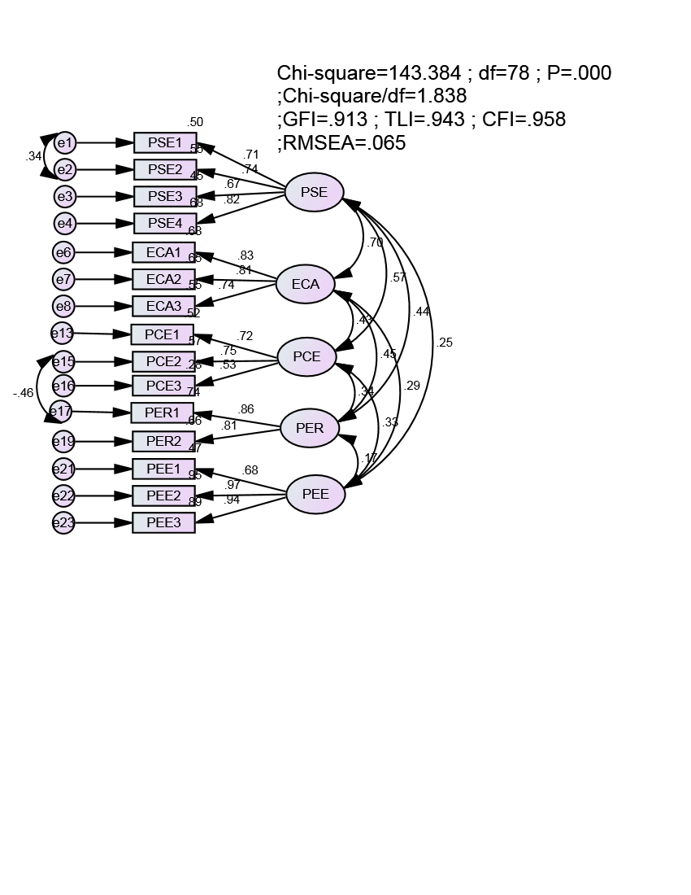

**Figure 2: Results of the scale CFA green purchasing behavior (normalized)**

**Source: Data analysis of research data in SPSS 22.0**

**4. Structural Equation Model Results**

The table shows the results of the goodness of fit test for the two constructs, namely, green environmental behavior and green purchasing behavior and, the resultant structural models of the two data sets. Various indices namely Absolute Fit Measures and Incremental Fit Measures were used to evaluate the model’s goodness-of-fit. As a commonly used statistic for model fit indexes, the Chi-square (X2) was employed in this study to examine the existence of any relationship between the variables in the model (Hair et al., 2006). From the AMOS output reflected in the table 6, it is clear that the model fitted the data well, and therefore proposed model was adequate in explaining the relationship among the variables.

**Table 6: Results of the AMOS Analyses of the Resultant Models. Source: Data analysis of research data in SPSS 22.0**

|  |  |  |  |  |  |  |  |  |  |  |
| --- | --- | --- | --- | --- | --- | --- | --- | --- | --- | --- |
|  |  |  |  | **Goodness of fit Measures** | |  |  |  |  |  |
| **Model** | **X2** | **Df** | **p** | **X2/df**  **(CMIN/DF)** | **RMSEA** | **NFI** | **RFI** | **IFI** | **TLI** | **CFI** |

Sample 133.672 87 0.001 1.536 .052 .922 .912 .971 .960 .971

Criteria P>.05 ≥0 - 2 to 3 <.08 >.90 >.90 >.90 >.90 >.90

(non-significant)

Note: X2 = hi-square test, df = Degrees of freedom, RMSEA = Root mean square error of approximation, NFI = Normed Fit Index, RFI = Relative Fit Index, IFI = Incremental Fit Index, TLI = Tucker-Lewis Index, CFI = Comparative Fit Index

*Inspection of the relationship between the environmental factors and green purchasing behavior*

Structural equation modeling (SEM) was performed to explore the relationship between the structure of green environmental behavior and green purchasing behavior. Tests the basic relationship between the elements (Perceived consumer effectiveness*,* Environmental concern and attitude*,* Perceived environmental responsibility*,* Perceived effectiveness of environmental behavior *and* Perceived seriousness of environmental problems) and Green purchasing behavior has been run.

The results showed that this model valuable chi-squared statistic is 133.672 with 87 degrees of freedom (p = 0.001). Chi-squared relative degrees of freedom according Cmin/df was 1.536 (< 2). Other indicators such as TLI = 0.960 (> 0.9), CFI = 0.971 (> 0.9) and RMSEA = 0.052 (<0.08). Therefore, this model achieved compatibility with data already collected. However, perceived effectiveness of environmental behavior (PEE) were excluded from the model because no statistically significant at the 95% confidence level for P = 0.078 values (> 0.05). The remaining factors include Perceived consumer effectiveness (PCE) (ES = 0.479; P = 0.004); Perceived seriousness of environmental problems (PSE) (ES = 0.283; P = 0.009), Environmental concern and attitude (ECA) (ES = 0.252; P = 0.030) and Perceived environmental responsibility (PER) (ES = 0.193; P = 0.048) had P values <0.05 and the estimated values are normalized so positive they have direct influence, positive full value).

**Table 7: Results of estimating causal relationships between these factors green purchasing behavior. Data analysis of research data by SPSS AMOS 22.0**

|  | **Relations** |  | **Estimate** | **S.E.** | **C.R.** | **P** | **Label** |
| --- | --- | --- | --- | --- | --- | --- | --- |
| GPB | <--- | PSE | 0.283 | 0.108 | 2.618 | 0.009 | accepted |
| GPB | <--- | ECA | 0.252 | 0.117 | 2.166 | 0.030 | accepted |
| GPB | <--- | PCE | 0.479 | 0.165 | 2.899 | 0.004 | accepted |
| GPB | <--- | PER | 0.193 | 0.097 | 1.981 | 0.048 | accepted |
| GPB | <--- | PEE | -0.105 | 0.060 | -1.763 | 0.078 | Not accepted |

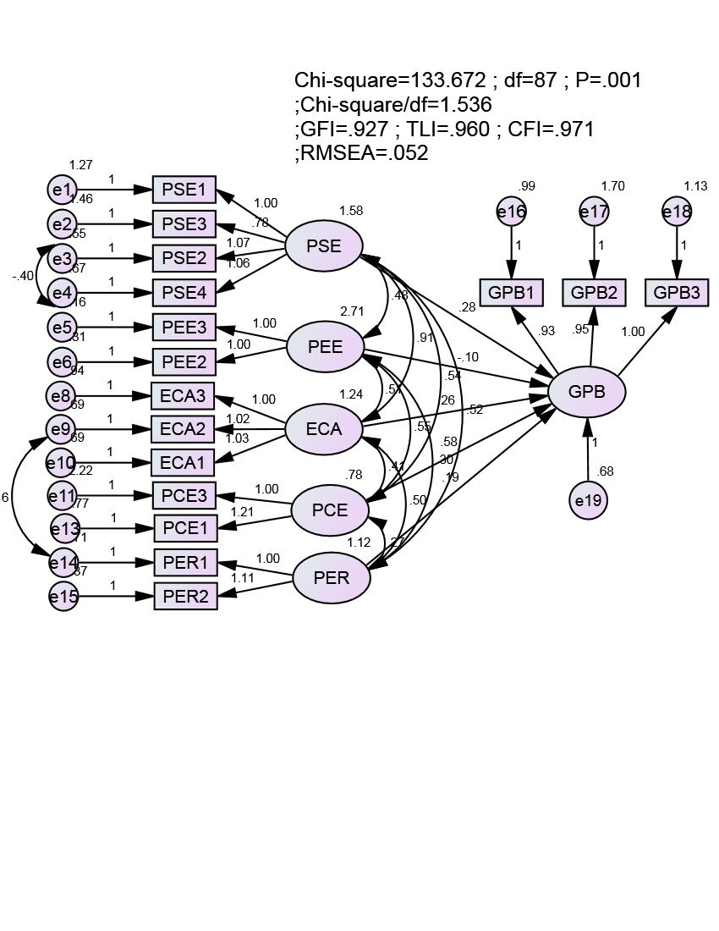

**Figure 4: Results of the model structure was SEM. Source: Data analysis of research data by SPSS AMOS 22.0**

The results showed that the model last calibration value chi-squared statistic is 104.719 with 65 degrees of freedom (p = 0.001). Chi-squared relative degrees of freedom according Cmin/df was 1.611 (<2). Other indicators such as GFI = 0.933 (> 0.9), TLI = 0.953 (> 0.9), CFI = 0.966 (> 0.9) and RMSEA = 0.055 (<0.08). Therefore, this model achieved compatibility with data already collected.

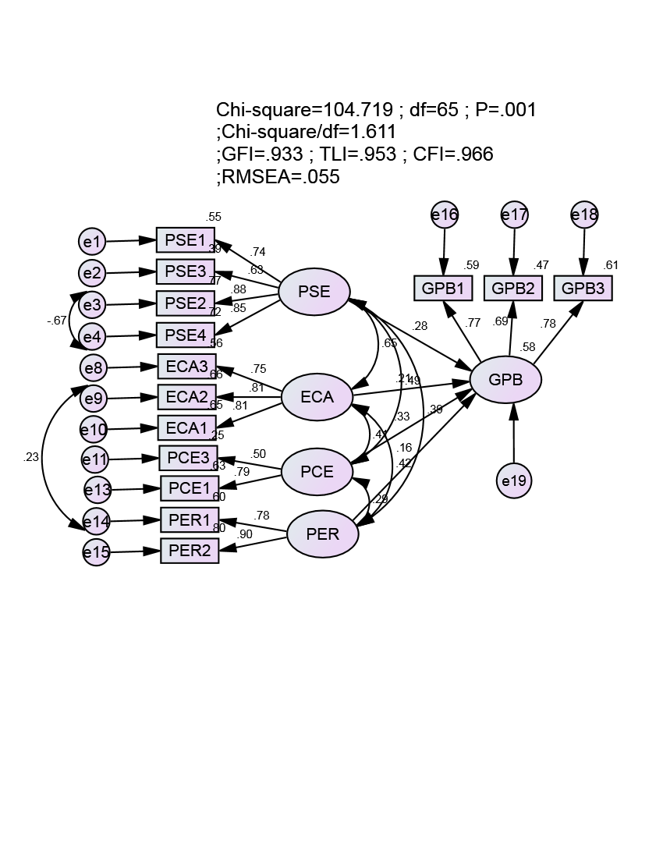

**Figure 4: Results of the model structure was last calibrated SEM. Source: Data analysis of research data by SPSS AMOS 22.0**

**Table 8: Results of estimating causal relationships between the elements of factors green purchasing behavior. Source: Data analysis of research data by SPSS AMOS 22.0**

|  | **Relations** |  | **Estimate** | **S.E.** | **C.R.** | **P** | **Label** |
| --- | --- | --- | --- | --- | --- | --- | --- |
| GPB | <--- | PSE | 0.296 | 0.107 | 2.771 | 0.006 | accepted |
| GPB | <--- | ECA | 0.242 | 0.119 | 2.037 | 0.042 | accepted |
| GPB | <--- | PCE | 0.506 | 0.165 | 3.066 | 0.002 | accepted |
| GPB | <--- | PER | 0.199 | 0.097 | 2.051 | 0.040 | accepted |

*Testing the reliability of estimates by Bootstrap*

Bootstrap method used to test the model estimates the last model with the pattern repeat is N = 1000. The estimation results from 1000 samples are averaged together with the deviations are presented in Table 9, CR very small absolute value than 2, it can be said that the deviation is very small; while not statistically significant at the 95% confidence level. Thus, we can conclude that the model estimates can be trusted.

As a result of testing of hypotheses for green purchasing behavior, the hypothesis H1, H2, H3 and H4 of the green purchasing behavior that are same direction relationship with the green purchasing behavior and are accepted. There are four relationships are worth theoretically.

**Table 9: Results estimated by bootstrap with N = 1000. Source: Data analysis of research data by SPSS AMOS 22.0**

|  |  |  |  |  |  |  |  |  |  |  |  |  |  |  |  |  |  |  |
| --- | --- | --- | --- | --- | --- | --- | --- | --- | --- | --- | --- | --- | --- | --- | --- | --- | --- | --- |
|  | |  | |  |  | | Estimate standard | | | |  | | Estimate Bootstrap with N=1000 | | | | | |
| **Parameter** | | | | | **Estimate** | | **SE** | | **SE-SE** | | **Mean** | | **Bias** | | **SE-Bias** | | **CR** | |
| GPB | <--- | | PSE | | 0.296 | 0.14 | | 0.003 | | 0.311 | | 0.005 | | 0.004 | | 1.250 | |
| GPB | <--- | | ECA | | 0.242 | 0.142 | | 0.003 | | 0.246 | | 0.004 | | 0.005 | | 0.800 | |
| GPB | <--- | | PCE | | 0.506 | 0.197 | | 0.004 | | 0.506 | | 0.001 | | 0.006 | | 0.167 | |
| GPB | <--- | | PER | | 0.199 | 0.176 | | 0.004 | | 0.188 | | -0.001 | | 0.006 | | -0.167 | |

**5. CONCLUSION**

***5.1. Results and Discussion***

This study has inheritance the previous studies (Chen & Chang (2012) by analyzing and assessing the impact of social Influences (concern, attitude, perceived and protection environment) of Green purchasing behavior. The study used data from the customers of Vietnam, has inherited the previous studies, conducted mainly in the Western countries.

The results confirm the positive relationship between Perceived Consumer Effectiveness with Green purchasing behavior (ES = 0.506, p = 0.002 <0.05). This result is consistent with most previous studies (Kim and Choi (2005)). However, whereas most previous studies here in the developed countries showed the opposite in Vietnam.

The findings show a positive effect of the Perceived Seriousness of Environmental Problems with Green purchasing behavior (ES = 0.296, p = 0.006 <0.05). This result is similar to those of most previous studies ( Lee, 2008) importance of the Perceived Seriousness of Environmental Problems is the weakest (Lee, 2009), this study confirms the Perceived Seriousness of Environmental Problems to be an important predictor of Green purchasing behavior).

The present results also confirm a positive relationship between the Environmental Concern and Attitude and Green purchasing behavior (ES = 0.242, p = 0.042 < 0.05). This result is consistent with most previous studies (Kotchen & Railing, 2008). Although the Environmental Concern and Attitude impact on Green purchasing behavior is weaker than that of the Perceived Consumer Effectiveness and Perceived Seriousness of Environmental Problems.

Finally, the results do not support a positive relationship between Perceived Effectiveness of Environmental Behavior and Green purchasing behavior (ES = -0.105, p= 0.078 > 0.05). This result is inconsistent with most previous studies (Koksal, M.H. and Kettaneh, T., 2011). However, it is worth noticing that although the effect of the Perceived Effectiveness of Environmental Behavior with Green purchasing behavior is not significant, the Perceived Effectiveness of Environmental Behavior correlates highly with other Green purchasing behavior. Thus, its effect on Green purchasing behavior may occur indirectly through other behaviors, such as concern, attitude, perceived and protection environment.

The study observed the factors that influenced green purchasing behavior consumers in Vietnam. Overall, it could be concluded that even though all predictors variable influenced the Green purchasing behavior but independently only 4 variables had the significant influence, they were:

1. Environmental concern and attitude

2. Perceived seriousness of environmental problems

3. Perceived environmental responsibility

4. Perceived consumer effectiveness

It found out that most of the respondents were aware of the environmental problems itself as they scored very high on the above variables, but they did not respond to it, they stayed at the level of knowing and concerning, they did not really actualize their concern into acts, because they thought that their acts would not affect much to the environment, as seen by variable Perceived environmental responsibility which had the lowest significance of all. The second factor which has the lowest significance is Environmental concern and attitude. It concluded that customers in Vietnam did not discuss so much about environmental issues nor environmentally friendly products with their friends. In addition, there were no significant gender differences between male and females with regards to Environmental concern and attitude, Perceived seriousness of environmental problems, Perceived effectiveness of environmental behavior and Perceived environmental responsibility

From this study it can be concluded that demographic variables have a significant impact on the consumers’ pro-environment/green purchasing behavior. Harris et.al (2000) notified that the environmentally conscious consumers are female, professional and younger. Kollmuss and Agyeman (2002) indicated the demographic factors to be one of the most influencing factors in pro-environmentally behavior. Hustad and Pessemier (1973) found that women’s education level has to be high to become consumerist/environmentally conscious consumers. Webster (1975) also found that socially conscious consumers typically are female..

***5.2. Implications for practical trading***

The study proposes findings that would be useful in the future and it was expected to be beneficial to those who were willing to participate in green marketing activities. The results indicated the high concern from the respondents with variables such as Environmental Concern and Attitude, Perceived Seriousness of Environmental Problems, Perceived Environmental Responsibility, and Perceived Consumer Effectiveness

For government, by knowing this situation, they should also take into account that young people were aware of the environmental problems, and they already concerned about the environment, therefore the government should concentrate more on inviting people to do some real acts for the environment.

Looking into the demographic results, marketers; companies or government can improve their promotion activities. Most respondents were aware of green products or green movement’s ads, most of them encountered it via Radio, followed by TV and Internet. These facts can be guidelines or considerations for them on their promotions in the future.

To sum up, whether they were green marketers, companies, government or educators, they had to be aware of these Environmental Concern, Perceived Seriousness of Environmental Problems, and Perceived Environmental Responsibility factors; to enhance the effect of those factors by doing promotion through the channels that they were most exposed to; and to turn those factors into action by conveying messages.

***5.3. Suggestions for Further Research***

Further research should be conducted into the effect of green purchasing behavior using a much larger sample in a different national setting to validate the findings of this study and to see if the measures developed here are statistically reliable and valid across different national settings. Future studies would benefit from exploring other behavior (e.g., Environmental Knowledge, informational or environmental, Availability of product information, Environmental awareness) that affect green purchasing behavior. Finally, this study has contributed to a more comprehensive understanding of the green purchasing behavior.

**Reference**

1. Akter, J. (2012), “*Consumer Attitude towards Green Marketing in Bangladesh”*, ASA University Review, Vol. 6 No. 1
2. Awan, U. and Raza, A.M. (2010). “*The role of green marketing in development of consumer behavior towards green energy”*, Master Thesis (EFO705), MIMA– International Marketing, School of Sustainable Development of Society and Technology, online retrieved on 6th October 2010.
3. Charter, M., & Tischner, U. 2001, “*Sustainable solutions: developing products and services for the future”*, Sheffield, UK: Greenleaf Publishing Limited.
4. Crosby, L.A., Gill, J.D. and Taylor, J.R., 1981. Consumer voter behavior in the passage of the Michigan Container Law. *Journal of Marketing,* (45), 349-354.
5. Dunlap, R. E. and Kent D. V. L., 1978. The new environmental paradigm. *Journal of Environmental Education*, 9 (4), 10-19.
6. Ellen, P.S., Wiener, J.L. and Cobb-Walgren, C., 1991. The role of perceived consumer effectiveness in motivating environmentally conscious behaviors’. *Journal of Public Policy and Marketing*, 10 (2), 102-117.
7. Grunert, S., 1993. Everybody seems concerned about the environment but is this concern reflected in Danish consumers’ food choice? *European Advances in Consumer Research,* (1), 428-433.
8. Harris, B., Burress, D. and Eicher, S., 2000. *Demand for local and organic product: a brief review of literature.* Kansas: University of Kansas Institute for Public Policy and Business Research.
9. Henion, Karl E., and Thomas C. Kinnear. 1976a. “*Ecological Marketing”.* Columbus, Ohio: American Marketing Association.
10. Hines, J., Hungerford, H. and Tomera, A., 1987. Analysis and Syntheses of research on environmental behaviour: A meta-analysis. *Journal of Environmental Education*, 18(2), 1-8.
11. Hustad, T.P. and Pessemier, E.A., 1973. Will the real consumer activists please stand up:

An examination of consumers’ opinions about marketing practices? *Journal of Marketing Research*, (10), 319-324.

1. Idowu, S. O., FIlho, W. L. 2009, “*Professionals perspective of corporate social responsibility, London”*, UK: Springer-Verlag Berlin Heidelberg.
2. Kim, Y. and Choi, S.R., 2005. Antecedents of green purchase behavior: An examination of collectivism, environmental concern and PCE. *Advances in Consumer Research*, 32(1), 592-599.
3. Knauer, V., 1973. Advertising and consumerism. *Journal of Advertising*, 2(1), 6-8.
4. Kollmuss, A. and Agyeman, J., 2002. Mind the gap: why do people act environmentally

and what are the barriers to pro-environmental behavior?. *Environmental Education*

*Research*, 8(3), 239-260.

1. Kotchen, M.J. and Reiling, S.D., 2000. Environmental attitudes, motivations and contingent valuation of nonuse values: A case study involving endangered species. *Ecological Economics*, 32(1), 93-107.
2. Lee, K. 2008. Opportunities for Green Marketing: Young Consumers Market, Intelligence & Planning, *Marketing Intelligence & Planning*, vol. 26(6), 573-586.
3. Lee, K. 2009. Gender Differences in Hong Kong Adolescent Consumers Green Purchasing Behavior, *Journal of Consumer Marketing*, vol. 26(2), 87-96.
4. Li, JJ and Su. C 2007. How face influences consumption: a comparative study of American and Chinese consumers, *International Journal of Market Research*, vol. 49(2) 237-56.
5. Macdonald, S, and Oates (2006), Sustainability: Consumer Perceptions and Marketing Strategies. *Business Strategy and the Environment*, Vol.15, 157-170.
6. Newhouse, N., 1991. Implications of attitudes and behavior research for environmental conservation. *The Journal of Environmental Education*, 22(1), 26-32.
7. Nupur, J. M. (2011), Green Marketing to Control Environmental Pollution in Bangladesh. Available at: http://www.scribd.com/doc/52823046/Green-Marketing-to-Control-Environmental-Pollution-in Bangladesh.
8. Polonsky, M. J. (1994), An Introduction to Green Marketing, Electronic *Green Journal*, ISSN: 1076-7975, 1(2), Article 3.
9. Ruiz,S., Arcas, N. and Cuestas, P., 2001. Consumer attitudes towards ecological agrarian

fruits and vegetables in Spain. A segmentation approach. *Acta Horiculturae*, 559, 681-686.

1. Shamdasani, Prem, Gloria Ong Chon-Lin, Daleen Richmond, 1993. Exploring Green Consumers In An Oriental Culture: Role Of Personal And Marketing Mix Factors, *Advances in Consumer Research*, (20) 491
2. Seguin, C., Pelletier, L. and Hunsley, J., 1998. Toward a model of environmental activism. *Environment and Behavior*, 30(5), 628-652.